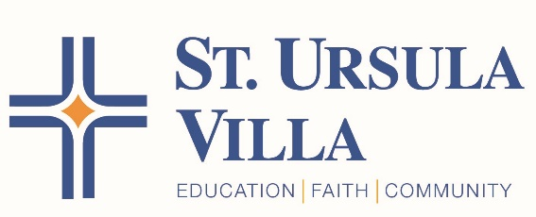

July 3, 2020

Dear St. Ursula Villa Parents,

We have been carefully outlining three school reopening plans: full in-person learning, a hybrid option with students learning both in school and virtually, and full remote learning. After thorough consideration of the restrictions and recommendations put forth in Governor DeWine’s "Ohio K-12 Schools Guidance Report" and guidance from medical advisors, we have determined that St. Ursula Villa will be able to start the school year by delivering full in-person learning with health and safety precautions in place. We are prepared to modify this plan should the situation in our community or the governor’s recommendations change. We recognize there may be a few exceptions in our community where full in-person learning may not be the best fit. We are committed to working with these families toward a solution, balancing both the health and educational needs of these students.
We will begin to communicate the details of our re-opening plan the week of July 15.

Stay safe and healthy and have a Happy Fourth of July weekend!

Kent Halaby and Lisa Wolfer

